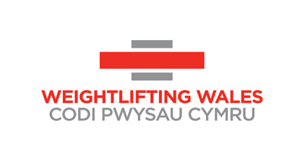
Weightlifting Wales Board Position Application
Please return this form along with a copy of your C.V. to hannah.powell@weightlifting.wales by 4th January 2021.

Name of Applicant
What skills would you bring to the board?

Sports Experience

Volunteering Experience

Professional Experience

